Test Case: tc002_SPX_Dev5_Crear_Requisicion_Spot_Con_FAD_Tipo_Cobro_CC
Step 1 - Enter username and password and click to button Enter : Credentials Entered
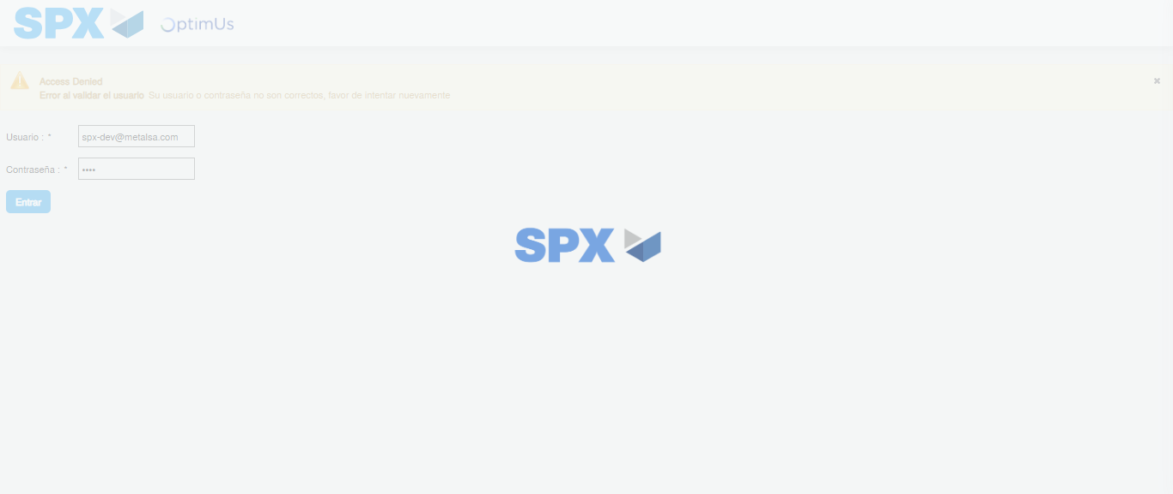Image file-name: QC_Testing-tc002_SPX_Dev5_Crear_Requisicion_Spot_Con_FAD_Tipo_Cobro_CC-1785976098843

Step 2 - Select to UEN and Access to Spot Buy Requisitions : UEN Correctly selected and Correct access
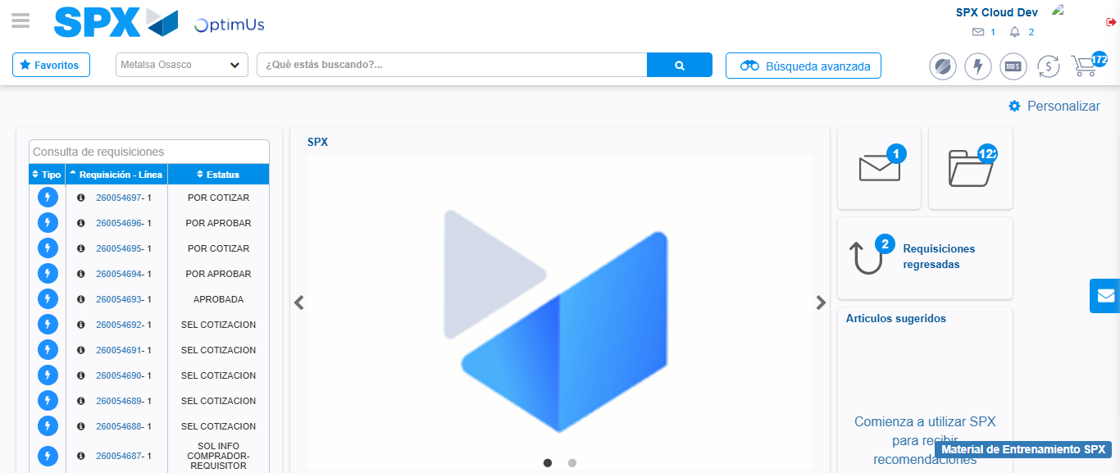Image file-name: QC_Testing-tc002_SPX_Dev5_Crear_Requisicion_Spot_Con_FAD_Tipo_Cobro_CC-1785976123683

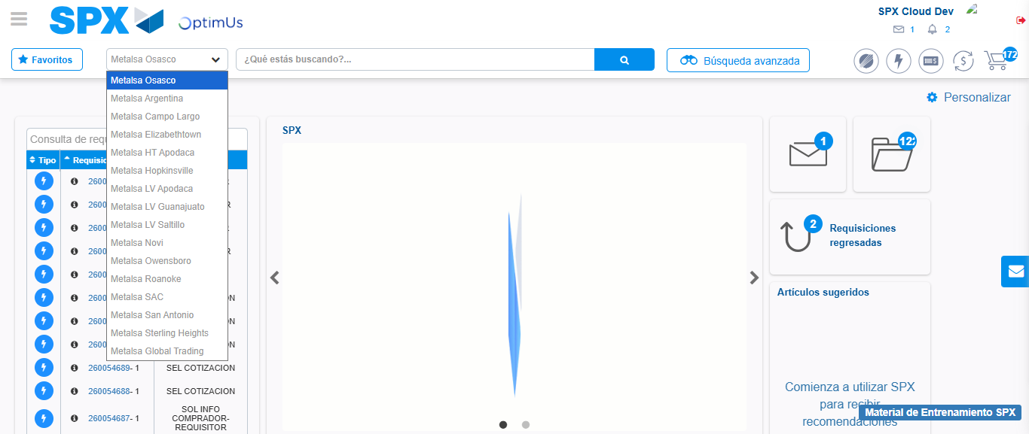Image file-name: QC_Testing-tc002_SPX_Dev5_Crear_Requisicion_Spot_Con_FAD_Tipo_Cobro_CC-1785976126502

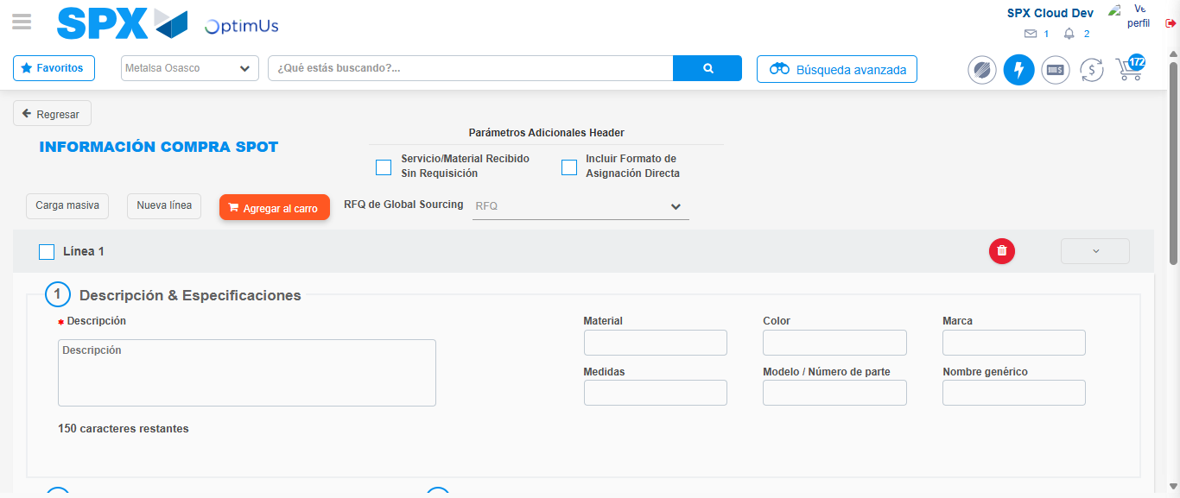Image file-name: QC_Testing-tc002_SPX_Dev5_Crear_Requisicion_Spot_Con_FAD_Tipo_Cobro_CC-1785976138539

Step 3 - Add FAD to Requisition: FAD Successfully Added
Image file-name: QC_Testing-tc002_SPX_Dev5_Crear_Requisicion_Spot_Con_FAD_Tipo_Cobro_CC-1785976138720

Image file-name: QC_Testing-tc002_SPX_Dev5_Crear_Requisicion_Spot_Con_FAD_Tipo_Cobro_CC-1785976138872

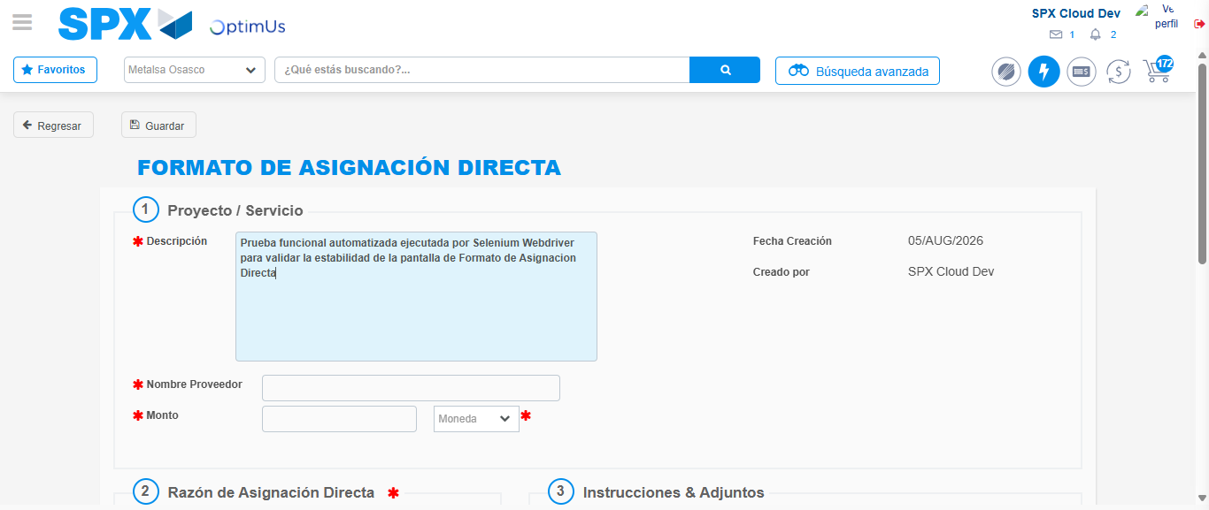Image file-name: QC_Testing-tc002_SPX_Dev5_Crear_Requisicion_Spot_Con_FAD_Tipo_Cobro_CC-1785976141598

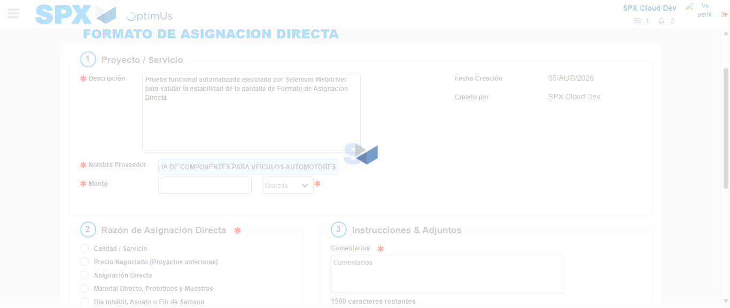Image file-name: QC_Testing-tc002_SPX_Dev5_Crear_Requisicion_Spot_Con_FAD_Tipo_Cobro_CC-1785976151189

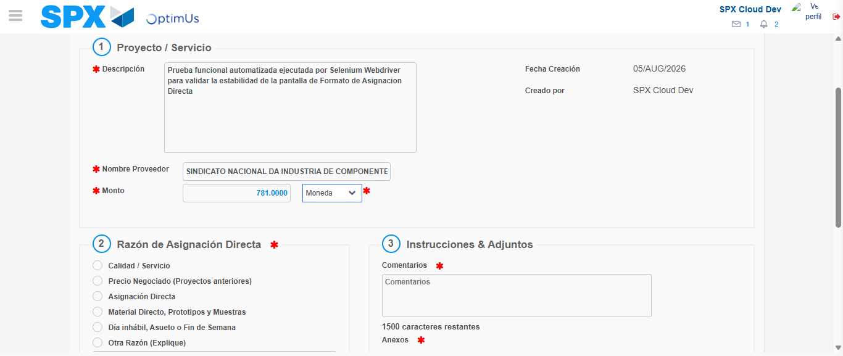Image file-name: QC_Testing-tc002_SPX_Dev5_Crear_Requisicion_Spot_Con_FAD_Tipo_Cobro_CC-1785976151599

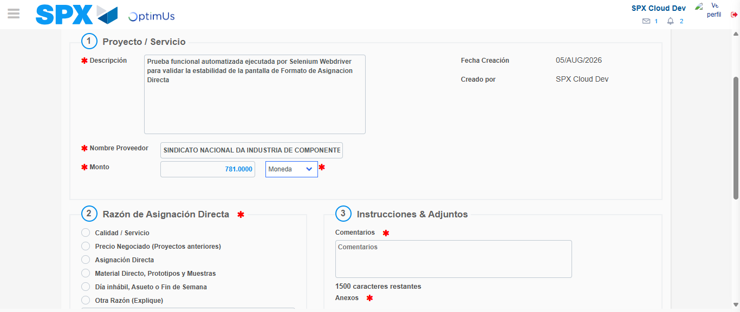Image file-name: QC_Testing-tc002_SPX_Dev5_Crear_Requisicion_Spot_Con_FAD_Tipo_Cobro_CC-1785976151794

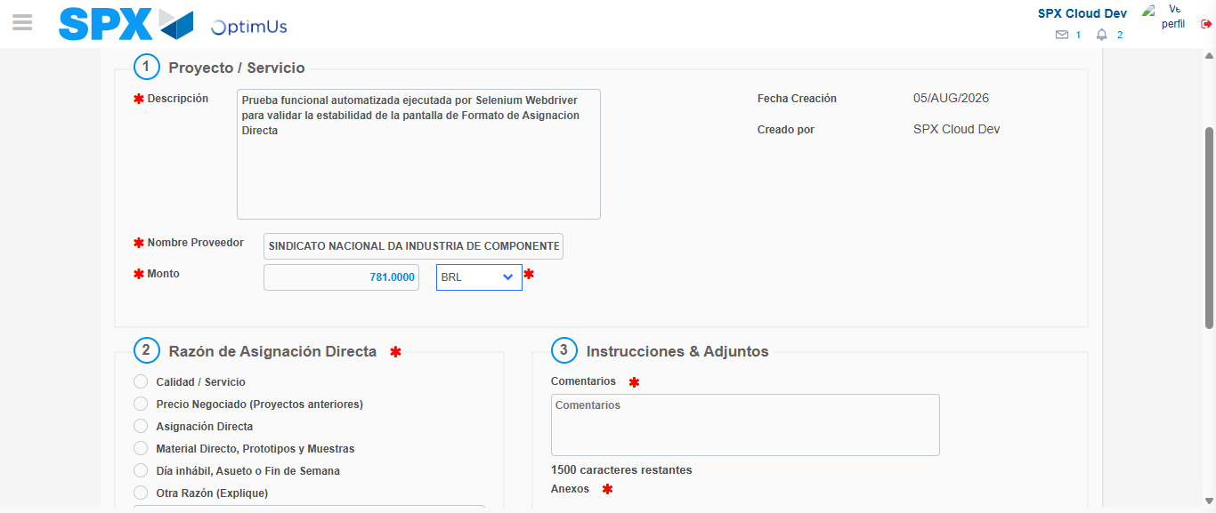Image file-name: QC_Testing-tc002_SPX_Dev5_Crear_Requisicion_Spot_Con_FAD_Tipo_Cobro_CC-1785976152122

Image file-name: QC_Testing-tc002_SPX_Dev5_Crear_Requisicion_Spot_Con_FAD_Tipo_Cobro_CC-1785976152279

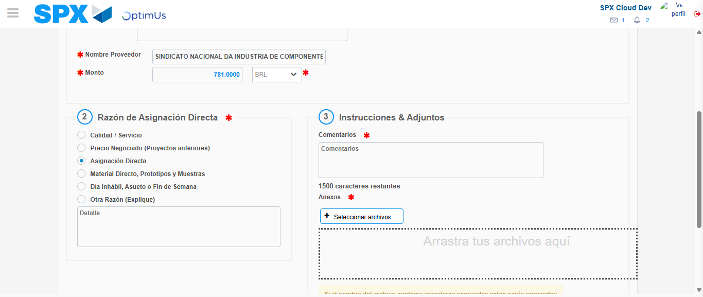Image file-name: QC_Testing-tc002_SPX_Dev5_Crear_Requisicion_Spot_Con_FAD_Tipo_Cobro_CC-1785976153153

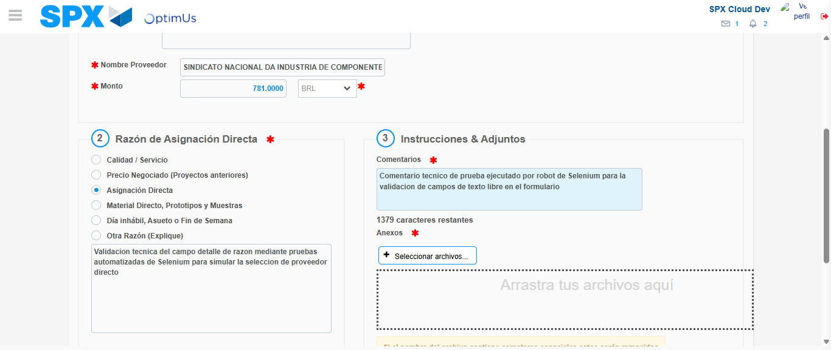Image file-name: QC_Testing-tc002_SPX_Dev5_Crear_Requisicion_Spot_Con_FAD_Tipo_Cobro_CC-1785976164261

Image file-name: QC_Testing-tc002_SPX_Dev5_Crear_Requisicion_Spot_Con_FAD_Tipo_Cobro_CC-1785976164994

Step 4 - Data Capture Spot Buy Requisition: Data captured correctly
Image file-name: QC_Testing-tc002_SPX_Dev5_Crear_Requisicion_Spot_Con_FAD_Tipo_Cobro_CC-1785976138720

Image file-name: QC_Testing-tc002_SPX_Dev5_Crear_Requisicion_Spot_Con_FAD_Tipo_Cobro_CC-1785976138872

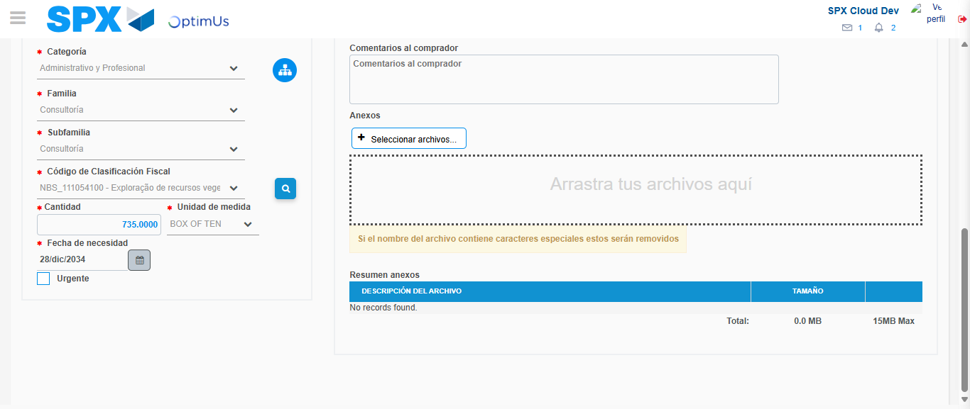Image file-name: QC_Testing-tc002_SPX_Dev5_Crear_Requisicion_Spot_Con_FAD_Tipo_Cobro_CC-1785976184731

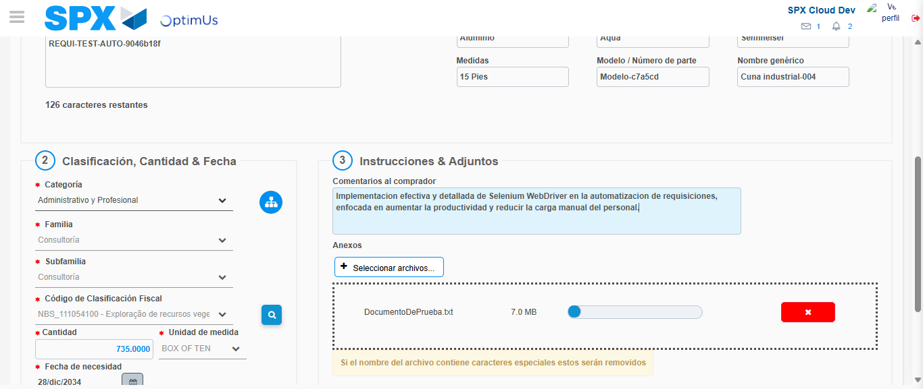Image file-name: QC_Testing-tc002_SPX_Dev5_Crear_Requisicion_Spot_Con_FAD_Tipo_Cobro_CC-1785976185624

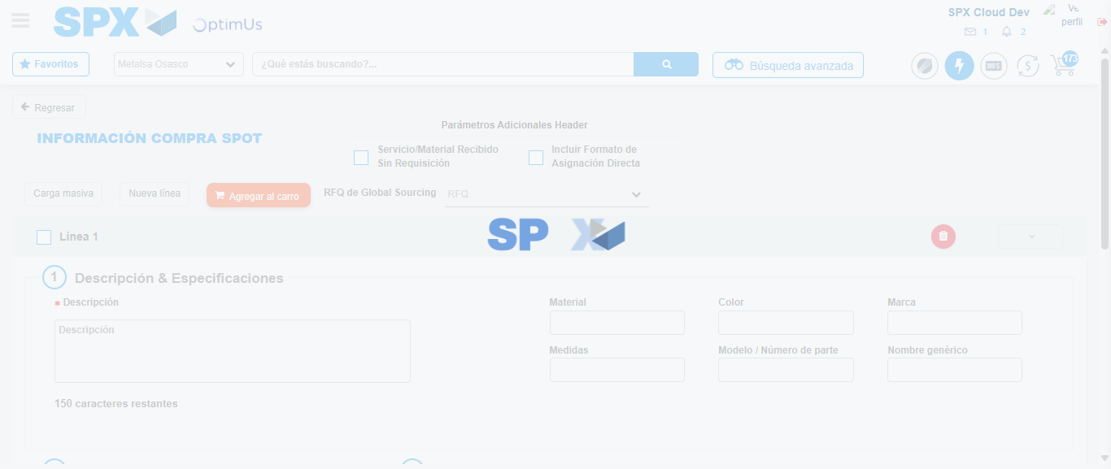Image file-name: QC_Testing-tc002_SPX_Dev5_Crear_Requisicion_Spot_Con_FAD_Tipo_Cobro_CC-1785976200495

Step 8 - Return to Main Page SPX : Return to Main Page SPX
Image file-name: QC_Testing-tc002_SPX_Dev5_Crear_Requisicion_Spot_Con_FAD_Tipo_Cobro_CC-1785976123683

Image file-name: QC_Testing-tc002_SPX_Dev5_Crear_Requisicion_Spot_Con_FAD_Tipo_Cobro_CC-1785976126502

Image file-name: QC_Testing-tc002_SPX_Dev5_Crear_Requisicion_Spot_Con_FAD_Tipo_Cobro_CC-1785976138539

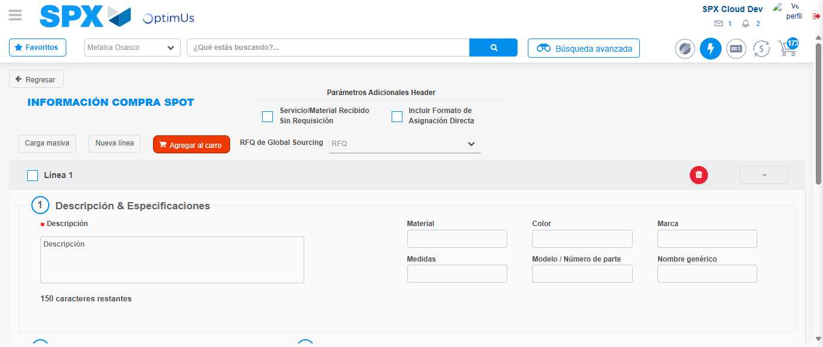Image file-name: QC_Testing-tc002_SPX_Dev5_Crear_Requisicion_Spot_Con_FAD_Tipo_Cobro_CC-1785976202733

Image file-name: QC_Testing-tc002_SPX_Dev5_Crear_Requisicion_Spot_Con_FAD_Tipo_Cobro_CC-1785976202873

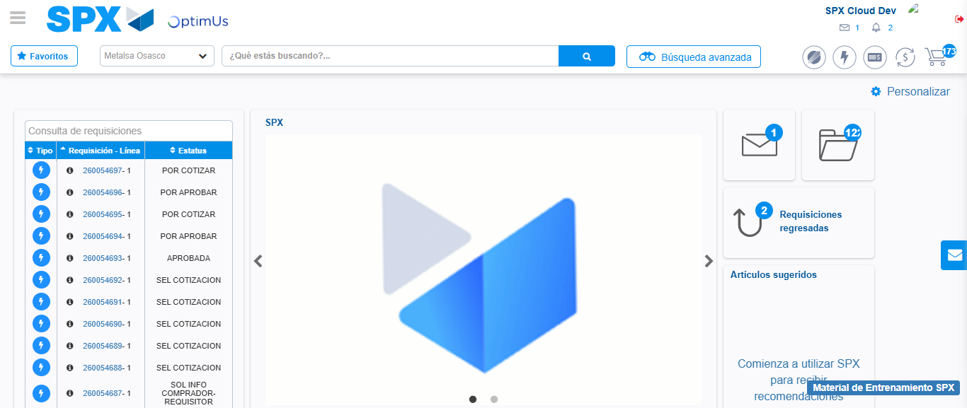Image file-name: QC_Testing-tc002_SPX_Dev5_Crear_Requisicion_Spot_Con_FAD_Tipo_Cobro_CC-1785976224193

Step 9 - Log Out : Log Out SPX
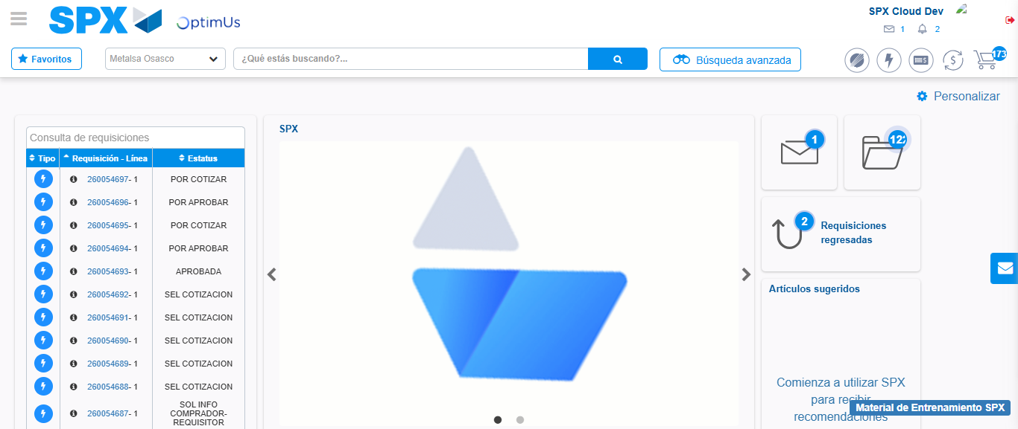Image file-name: QC_Testing-tc002_SPX_Dev5_Crear_Requisicion_Spot_Con_FAD_Tipo_Cobro_CC-1785976224551

